News From: BH Properties
Media Contact: Gary Marsh (415) 453-7045 or gary@marshmarketing.com
BH Properties Acquires Scottsdale Office Building
Scottsdale, AZ (November 17, 2015) – Steve Gozini, President and CEO of BH Properties, announced today that his firm has acquired a 10,150 square foot, two-story office building in Scottsdale for $925,000.
The vacant property is located at 10799 North 90th Street, just one mile to the loop 101 and near the HonorHealth Scottsdale Shea Medical Center, restaurants and retail. The property is ideal for an office or medical tenant, and can easily be designed for single or multi-tenant use. Built in 1987 and renovated in 2007, the masonry with stucco facade building has 42 covered parking spaces, and sits on a 30,555 square foot lot.

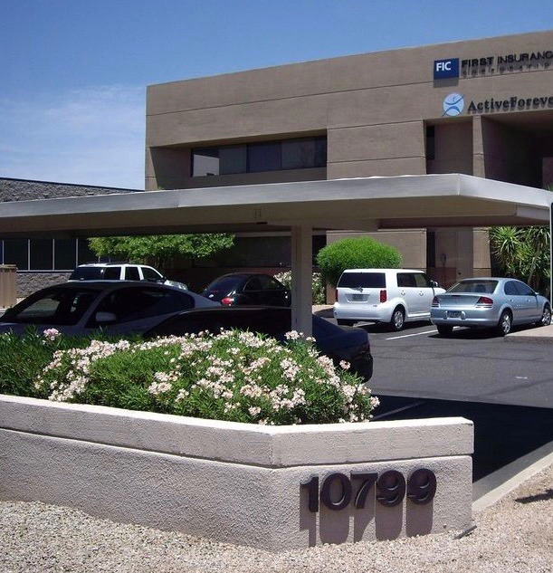
“This office building is very well located in Scottsdale within close proximity to the HonorHealth Scottsdale Shea Medical Center, the 101 Loop, retail and residential areas,” says Andrew Van Tuyle, Chief Acquisitions Officer at BH Properties. “We felt this was a very good value-add opportunity in the Scottsdale marketplace with the right basis for our portfolio,” he added.
Geoff Turbow with LevRose Commercial Real Estate represented the seller, CRE Ventures XXXI, LLC. BH Properties represented itself in the transaction.
About BH Properties
BH Properties acquires and maximizes the value of underperforming office, industrial, retail and multifamily properties by seeking out properties with excessive vacancy or otherwise in need of new vision. The company repositions these assets and patiently seeks out the right tenants for the location. With upgrades and refurbishing, BH Properties successfully transforms its properties into attractive, consistently profitable investments and currently manages a portfolio of more than 120 properties in 17 states that comprise of over 10 million square feet of commercial space and approximately 3,500 apartment homes. Headquartered in Los Angeles, CA, the firm has regional offices in Dallas, Salt Lake City and Phoenix. Its core markets are Arizona, California, Colorado, New Mexico, Nevada, Oregon, Texas and Utah. BH Properties is known for its ability to make fast commitments with acquisitions and to close quickly. Learn more at www.bhproperties.com.

